1. Introduction
Pediatric ureteral stents are medical devices used for the maintenance of urine drainage from the kidney to the bladder in children with obstructive uropathy or during/after procedures such as glansplasty (De Grazia et al., 2019; Alsaywid et al., 2024). Unlike adult stents, pediatric stents require a closer consideration of smaller anatomical dimensions and unique physiological requirements (De Grazia et al., 2019). The clinical challenges of pediatric ureteral stenting include encrustation, biofilm formation, and migration, and are potentially influenced by stent geometry and flow dynamics (Tomer et al., 2021). Optimizing stent design to maximize drainage efficiency while minimizing pressure drop remains a significant biomechanical engineering challenge.
Traditional stent design optimization relies heavily on iterative prototyping and computational fluid dynamics (CFD) simulations using software, such as COMSOL Multiphysics (COMSOL, 2024). While CFD can provides high fidelity predictions of flow behavior, each simulation can require 2-4 hours of computation time, making exhaustive design space exploration computationally prohibitive (Queipo et al., 2005; Forrester et al., 2008). This limitation motivates the development of machine learning-based surrogate models that can drastically reduce stent performance prediction times, enabling efficient exploration of the design space (Forrester et al., 2008).
The concept of using surrogate models for engineering optimization is already well-established in aerospace and mechanical engineering domains (Queipo et al., 2005). Recent advances in Gaussian Process Regression (GPR) provide principled uncertainty quantification, which is critical for active learning strategies that adaptively select new simulation points (Rasmussen & Williams, 2006). In addition, applications of surrogate-based optimization to cardiovascular stent design have demonstrated substantial improvements in design efficiency (Ribeiro et al., 2021).

1.1 Specific Aims
Aim 1: Develop a Parametric CAD Framework for Pediatric Stent Design. The first aim of this project is to establish a comprehensive parametric design framework that enables systematic exploration of pediatric ureteral stent geometries. This framework will define several key design variables, and Latin Hypercube Sampling (LHS) will be implemented to efficiently generate diverse design candidates that span the feasible parameter space.
Aim 2: Train a Machine Learning Surrogate Model on CFD Simulation Data. The second aim focuses on developing a GPR surrogate model trained on COMSOL Multiphysics CFD simulation outputs. Following the methodology of <paper is still being written but ______ et al. 2026 or just use aua abstract>, this surrogate will approximate the mapping from design parameters to key performance metrics including outlet flow rate (Q_out), pressure drop (ΔP), and side-hole flux distribution (Q_SH).
Aim 3: Implement Active Learning Multi-Objective Optimization (ALMO). The third aim is to establish an active learning optimization loop that iteratively identifies optimal stent designs. This framework will perform Pareto optimization to simultaneously optimize all or different subsets of the aforementioned performance metrics. Promising candidate designs will be validated through targeted COMSOL simulations, with results fed back into the surrogate to improve its predictions. This iterative process continues until convergence.

2. Methods

2.1 Design Variables
The stent design space is defined by a set of parametric variables that control the geometry of the stent. These parameters were selected based on their influence on hydraulic performance as established in the ureteral stent literature (De Grazia et al., 2019), as well as manufacturability constraints from clinical stent specifications.
French size (outer diameter) is clinically constrained and can dominate hydraulic performance. To avoid trivial optima driven only by choosing the largest diameter, we treat French size as a discrete clinical setting and report/optimize designs conditionally. This will result in Pareto fronts produced per French (up in air whether to do this or just have it be per a small set of clinically realistic Fr values), with other geometric variables optimized within each Fr stratum.

2.1.1 Input Parameters (Check .xsls for full list; this is not updated)
Parameter | Description | Unit | Range
Stent French | Outer diameter of stent | Fr | 4.0 – 8.0
Stent Length | Total length of stent body | mm | 100 – 300
Side Hole Diameter | Diameter of drainage side holes | mm | 0.5 – 3.0
Coil Radius | Radius of pigtail retention coil | mm | 5 – 15
Coil Length | Length of pigtail coil segment | mm | 10 – 50
Pigtail Angle | Angular wrap of retention coil | ° | 270 – 360
N_proximal | Number of proximal side holes | count | 0 – 10
N_middle | Number of middle side holes | count | 0 – 15
N_distal | Number of distal side holes | count | 0 – 10
Wall Thickness | Thickness of stent wall | mm | 0.15 – 0.4

2.1.2 Output Variables (COMSOL Simulation)
The following output metrics are extracted from COMSOL CFD simulations, based on the flow parameters identified as clinically significant.
Variable | Description | Unit
Q_out | Total outlet flow rate | mL/min
ΔP (delta_P) | Pressure drop (P_in − P_out) | Pa
Q_SH1 | Flow through first (proximal) side hole | mL/min
Q_SHmid | Flow through middle side hole | mL/min
Q_SHend | Flow through last (distal) side hole | mL/min

2.2 CAD Model Generation
Parametric CAD models are generated programmatically using the Python-based CAD library build123d, because it enables fully scriptable, reproducible geometry construction. For each design point in the parameter space, a complete 3D stent geometry is created including the main tubular body, pigtail retention coils at proximal and distal ends, and side holes distributed according to the specified parameters. The generated models are exported in STEP format for import into COMSOL Multiphysics.
To efficiently explore the design space, LHS will generate a set of design points that uniformly covers the multi-dimensional parameter space.

2.3 Computational Fluid Dynamics Simulation
CFD simulations are performed in COMSOL Multiphysics 6.0 using the Laminar Flow (spf) physics interface (COMSOL, 2024). Each stent geometry is imported, meshed using physics-controlled tetrahedral elements, and simulated under standardized boundary conditions representing physiological urine flow. The simulations solve the steady-state Navier-Stokes equations:
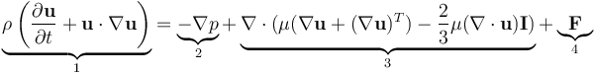
Boundary conditions include a prescribed inlet pressure (P_in = 10-15 cm H2O, representing typical renal pelvic pressure) and zero-pressure outlet <still not sure if this will be held constant/the only environment that will be tested> .
Batch processing via COMSOL Application Builder is utilized to automate the simulation of multiple design configurations. Results are exported as structured CSV files containing the design ID and corresponding output values. Mesh convergence studies confirm grid-independent solutions with relative errors < 1%.

2.4 Surrogate Model Development
A machine learning surrogate model is trained to approximate the mapping from design parameters (14 dimensions currently) to COMSOL output metrics (5 dimensions for sure now; subject to increase). Input parameters are scaled to [0,1] using the training-set bounds to improve kernel length-scale interpretability and numerical conditioning. Each output metric is z-scored (ỹ = (y−ȳ)/s_y) prior to GP fitting; predictions are back-transformed for reporting.
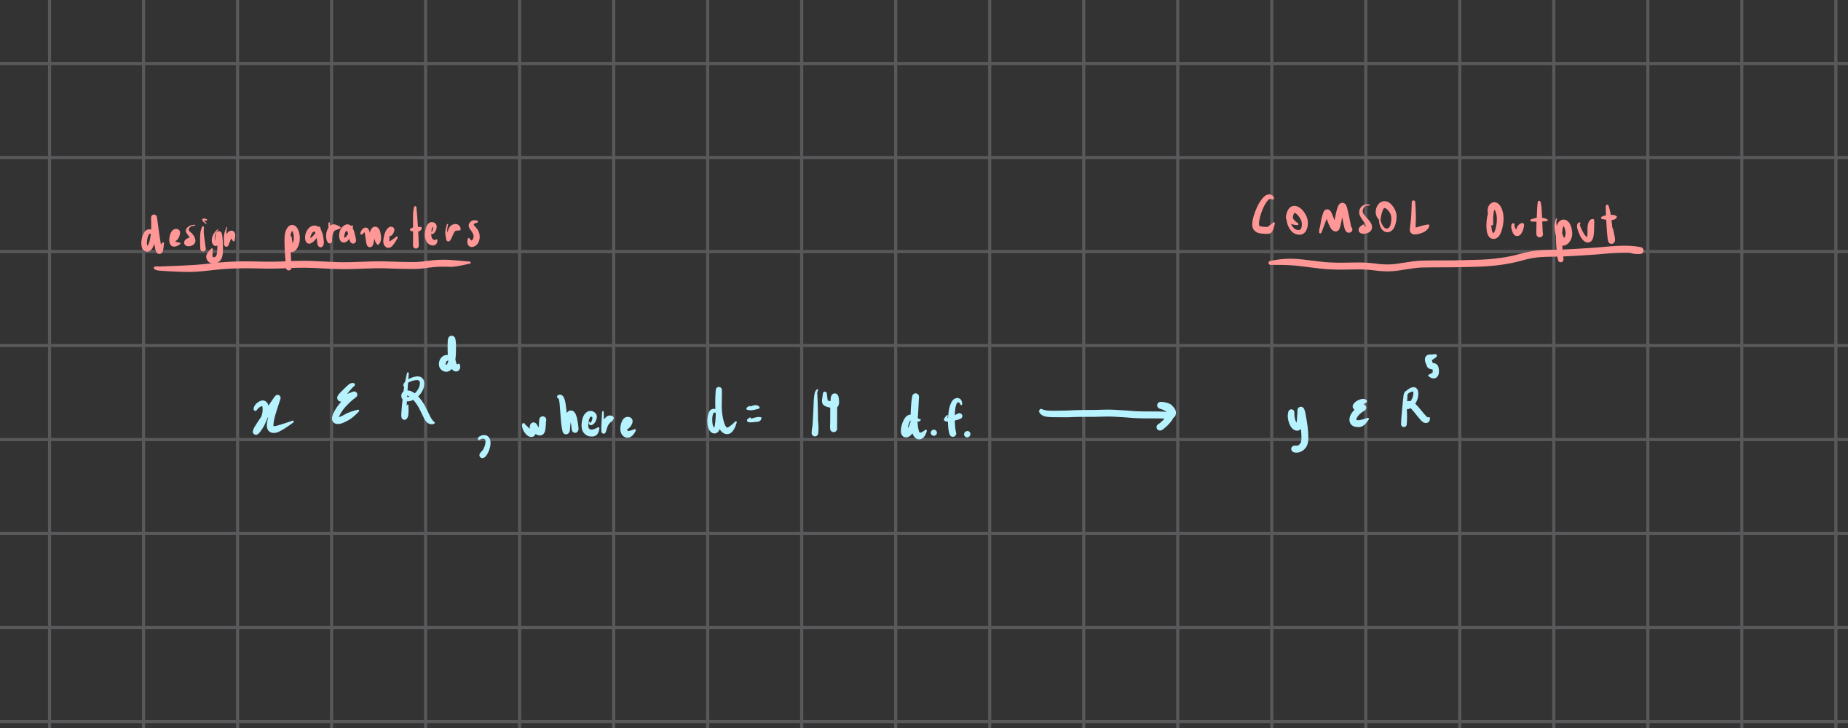
A separate GP is fit per output metric (independent-output model). This keeps training stable in the low-data regime and supports both single-objective EI and multi-objective EHVI/qNEHVI.

2.4.1 Gaussian Process Regression
The primary surrogate model is Gaussian Process Regression (GPR), a Bayesian non-parametric approach that defines a distribution over functions:
f(x) ~ GP(m(x), k(x, x′))
where m(x) is the mean function and k(x, x′) is the covariance kernel. The current kernel selected is the Matern 5/2 kernel, which is commonly used for physical systems (Snoek et al., 2012), but if this is not a good description of the x/x’ relationships, then other preconfigured stationary kernels, like the Matern 3/2, are also options. We may also choose to calibrate for different kernels at different stent locations. For example:
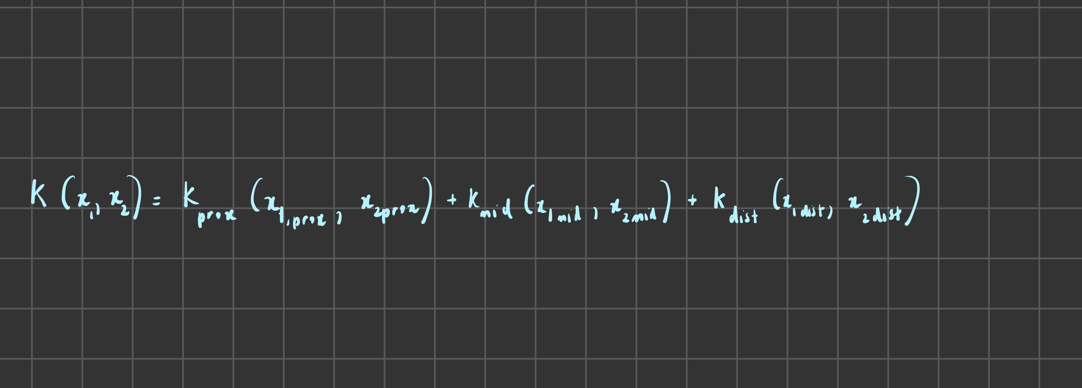
The posterior predictive distribution provides both the mean prediction and variance σ²(x).

2.4.2 Alternative Models
For comparison, we also evaluate:
- Random Forest Regression
- Gradient Boosting (XGBoost)
- Multi-layer Perceptron
Hyperparameter tuning is performed using Bayesian optimization via Optuna (Akiba et al., 2019) with 5-fold cross-validation. Model performance is evaluated using R² score, mean absolute error (MAE), and root mean squared error (RMSE) on a held-out test set (~20% of data).

2.5 Multi-Objective Optimization
Multi-objective optimization is performed on the trained surrogate model to identify Pareto-optimal stent designs.
Pareto fronts are reported conditionally on stent French size (Fr). Specifically, we compute separate Pareto fronts for each clinically realistic Fr (or a small set of Fr values), since diameter is not freely selected by the surgeon, but is instead based on availability + patient anatomy size, and strongly affects hydraulic performance. This yields per-Fr tradeoffs among geometric features that are actually actionable within a given size selection.
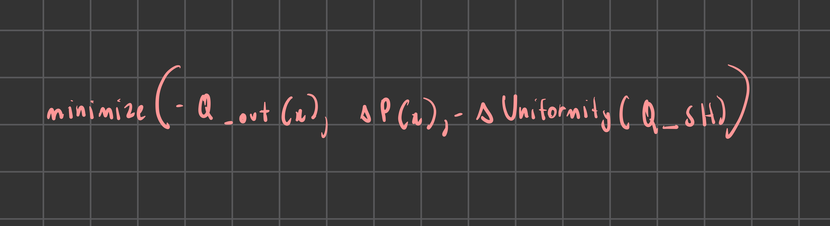The objectives correspond to clinical requirements:
- Maximize outlet flow rate (Q_out) to ensure adequate drainagex
- Minimize pressure drop (ΔP) to prevent hydronephrosis
- Maximize flow uniformity across side holes to reduce encrustation risk
Optimization is performed using NSGA-II for Pareto front identification, and Bayesian optimization with Expected Hypervolume Improvement (EHVI) for sample-efficient optimization (Emmerich et al., 2006).

2.6 Active Learning Loop
An active learning framework enables iterative refinement of the surrogate model while simultaneously optimizing design objectives. This approach is usually termed Active Learning Multi-Objective Optimization (ALMO) loop (Zuluaga et al., 2013).
This project will have a ALMO loop that proceeds as:
1. Train GPR surrogate on available COMSOL simulation data
2. Compute EHVI over parameter space
3. Select design points that maximize acquisition value
4. Run COMSOL simulations on selected designs
5. Augment training dataset with new simulation results
6. Repeat until convergence (Pareto front stability or budget exhaustion)
This balances exploration (sampling uncertain regions) with exploitation (refining set with statistically promising designs), typically requiring 3-5x fewer simulations than uniform sampling to achieve comparable Pareto front quality (Zuluaga et al., 2016).

2.7 Validation
Final optimal designs identified through surrogate-based optimization are validated by running full COMSOL simulations. The predicted and simulated output values are compared using relative error metrics. Surrogate accuracy targets are (currently, also subject to change) R² > 0.95 and RMSE < 5% of the output range. Additionally, leave-one-out cross-validation (LOOCV) is performed to assess predictive performance across the design space.

References
Akiba, T., Sano, S., Yanase, T., Ohta, T., & Koyama, M. (2019). Optuna: A next-generation hyperparameter optimization framework. Proceedings of the 25th ACM SIGKDD International Conference on Knowledge Discovery & Data Mining (KDD), 2623–2631.
COMSOL Multiphysics. (2024). Reference Manual (Version 6.2). COMSOL AB.
Emmerich, M. T. M., Giannakoglou, K. C., & Naujoks, B. (2006). Single- and multiobjective evolutionary optimization assisted by Gaussian random field metamodels. IEEE Transactions on Evolutionary Computation, 10(4), 421–439.
Forrester, A. I. J., Sóbester, A., & Keane, A. J. (2008). Engineering Design via Surrogate Modelling: A Practical Guide. Wiley.
Alsaywid, B. S., Mesawa, A. A., Mohammedkhalil, A. K., Almarghoub, M., Barnawi, Z., & Abuznadah, W. T. (2019). Antibiotic prophylaxis in children with ureteric stents: reduction of symptomatic urinary tract infections. Urology Annals, 11(2), 123–130.
Maulik, R., Fukami, K., Ramachandra, N., Fukagata, K., & Taira, K. (2020). Probabilistic neural networks for fluid flow surrogate modeling and data recovery. Physical Review Fluids, 5(10), 104401.
Queipo, N. V., Haftka, R. T., Shyy, W., Goel, T., Vaidyanathan, R., & Tucker, P. K. (2005). Surrogate-based analysis and optimization. Progress in Aerospace Sciences, 41(1), 1–28.
Rasmussen, C. E., & Williams, C. K. I. (2006). Gaussian Processes for Machine Learning. MIT Press.
Ribeiro, N. S., et al. (2021). Surrogate-based multi-objective design optimization of a representative coronary stent platform. Computer Methods in Biomechanics and Biomedical Engineering.
Snoek, J., Larochelle, H., & Adams, R. P. (2012). Practical Bayesian optimization of machine learning algorithms. Advances in Neural Information Processing Systems.
Tomer, N., Zhao, A., & Singla, N. (2021). Ureteral stent encrustation: Epidemiology, pathophysiology, management and current technology. AUANews.
Zuluaga, M., Sergent, G., Krause, A., & Püschel, M. (2013). Active learning for multi-objective optimization. Proceedings of the 30th International Conference on Machine Learning (ICML).
Zuluaga, M., Krause, A., & Püschel, M. (2016). ε-PAL: An active learning approach to the multi-objective optimization problem. Journal of Machine Learning Research, 17(104), 1–32.

2.5 Model Pipeline Decisions

2.5.1 Notation
Design vector:

represents a single stent geometry instance in parameter space, where d has 12–14 effective dimensions currently.
Training dataset: 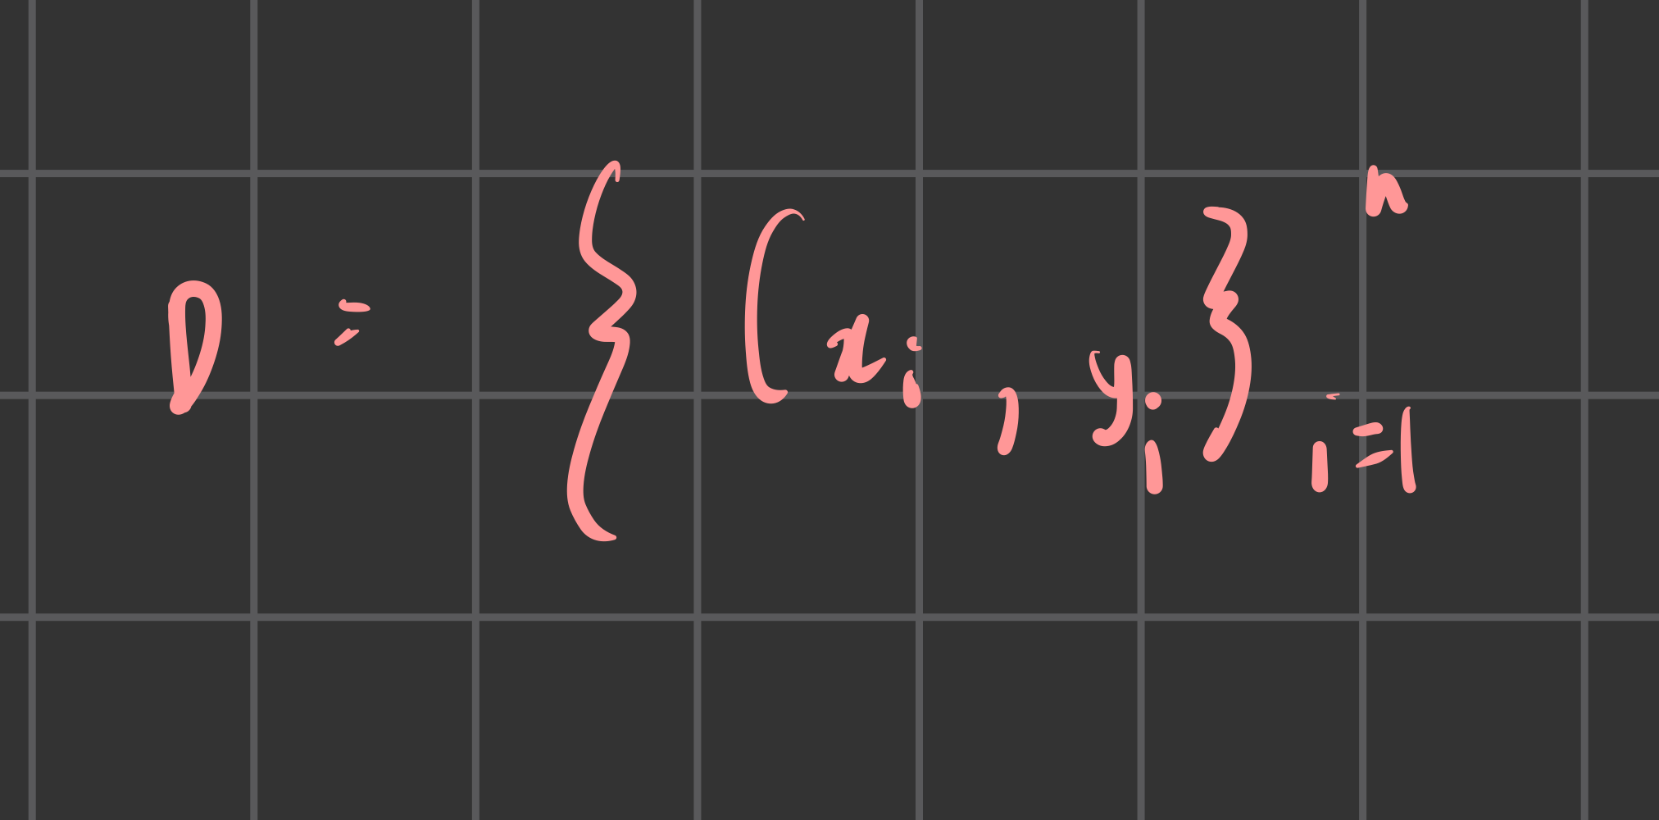 from COMSOL simulations.
Outputs: 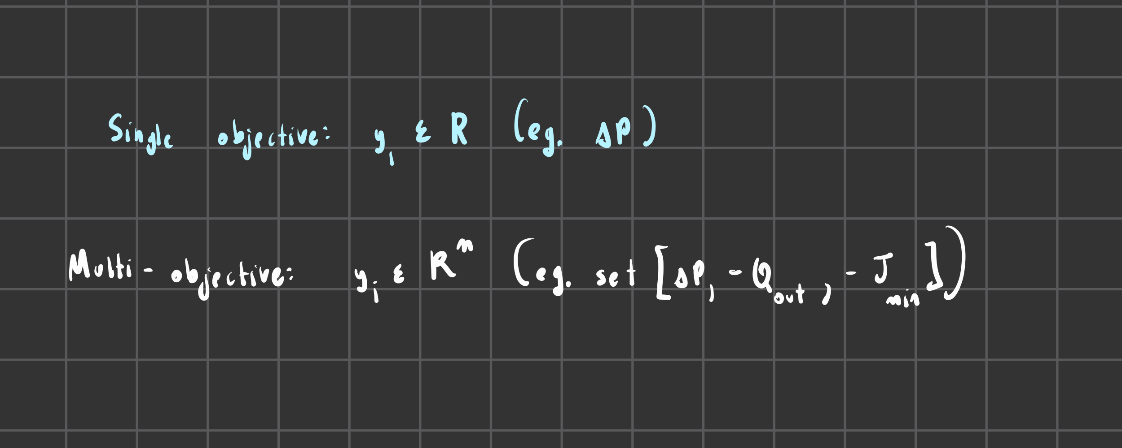

2.5.2 Parameterization: Sampled vs Derived
Direct sampling: Parameters that can be sampled independently without invalidating geometry (stent_french, stent_length, coil parameters, section lengths, hole counts, unroofed_length, r_end fraction).
Derived parameters: Computed to preserve validity:
• L_mid = L_total − 2L_coil − L_prox − L_dist (enforcing L_mid ≥ L_mid,min)
• d_end = min(r_end · ID, ID − buff) where buff = 0.15 mm buffer
• ID = OD − 2t (enforcing ID ≥ ID_min)
Feasibility rules: <tbd>

2.5.3 Objective Strategy
Policy: Start single-objective or scalarization → graduate to Pareto when calibration is trusted.
Calibration criteria:
• Coverage ≈ 0.95
• RMSE on blocked/corner holdouts not exploding
• NLPD acceptable
Rationale: Pareto acquisitions (namely qNEHVI) rely heavily on uncertainty in multiple dimensions. Poor calibration in regard tos uncertainty will cause to exploration of fake tradeoffs.

2.5.4 Initial Sampling Plan
Latin Hypercube Sampling (LHS): Generates the initial stent parameter set X_0 to be space-filling
Feasibility filtering: n_raw = α·n_0 (α = 3) → keep first n_0 feasible designs
Sample size rule: For d ~ 12 effective dimensions:
• Low budget: n_0 ~ 3d (36)
• Standard: n_0 ~ 5d (60) / current choice
• Comfortable: n_0 ~ 8d (96)

2.5.5 Surrogate Model Specification
Justification for Gaussian Assumption: Recent work by Maulik & Taira (2020) in Physical Review Fluids validates the use of Gaussian distributions for fluid flow surrogate modeling. Their Probabilistic Neural Network (PNN) approach explicitly models flow variables as samples from a conditional Gaussian distribution to quantify uncertainty. Our approach leverages this same physical validity but adapts the utility for the data-sparse regime: while Taira’s PNN requires large datasets (O(10^3)) to learn the Gaussian structure via weights, our use of a Gaussian Process allows for exact Bayesian inference on small datasets (O(10^2)), providing the necessary uncertainty quantification for active learning without the prohibitive computational cost of generating thousands of training simulations.
Gaussian Process
Posterior predictive
Alternatives (as baselines): Polynomial RSM for sanity checking; XGBoost/NN ensembles if n grows large.

2.5.6 GP Configuration
Kernel: Matern 5/2 (twice differentiable, smooth but not infinitely so). (Only rationale currently si that it voids RBF oversmoothing/overconfidence)
ARD length-scales:
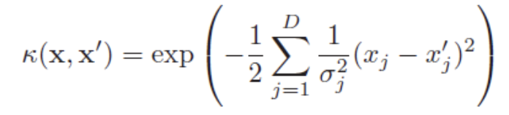
Noise term: Most likely will include even for "deterministic" COMSOL due to numerical/meshing jitter and geometry-conditioning effects

2.5.7 Hyperparameter Fitting
Numerical stability: NLML optimization uses Cholesky factorization.
Log marginal likelihood: 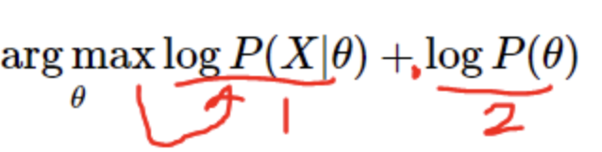

2.5.8 Validation Strategy
Blocked/region holdout: Hold out entire parameter regions (e.g., {x : x_Fr ∈ [7,8]}) to test interpolation in not yet explored areas.
Corner/extremes holdout: Hold out designs near parameter bounds to stress test extrapolation stress
Metrics: RMSE, MAE, NLPD
Figures: tbd; view pptx

2.5.9 Acquisition Functions
Single-objective EI
Multi-objective (EHVI/qNEHVI): Enable when calibration criteria pass.

2.5.10 Active Learning Loop
Initialization: X_0 ~ LHS(𝒳), Y₀ = COMSOL(X_0)
Iteration (t = 0, 1, ...):
1. Fit GP on D_t via NLML
2. Select batch: X_{t+1}
3. Run COMSOL: Y_{t+1} = COMSOL(X_{t+1})
4. Update: D_{t+1} = D_t ∪ {(X{t+1}, Y_{t+1})}
Under current bounds:
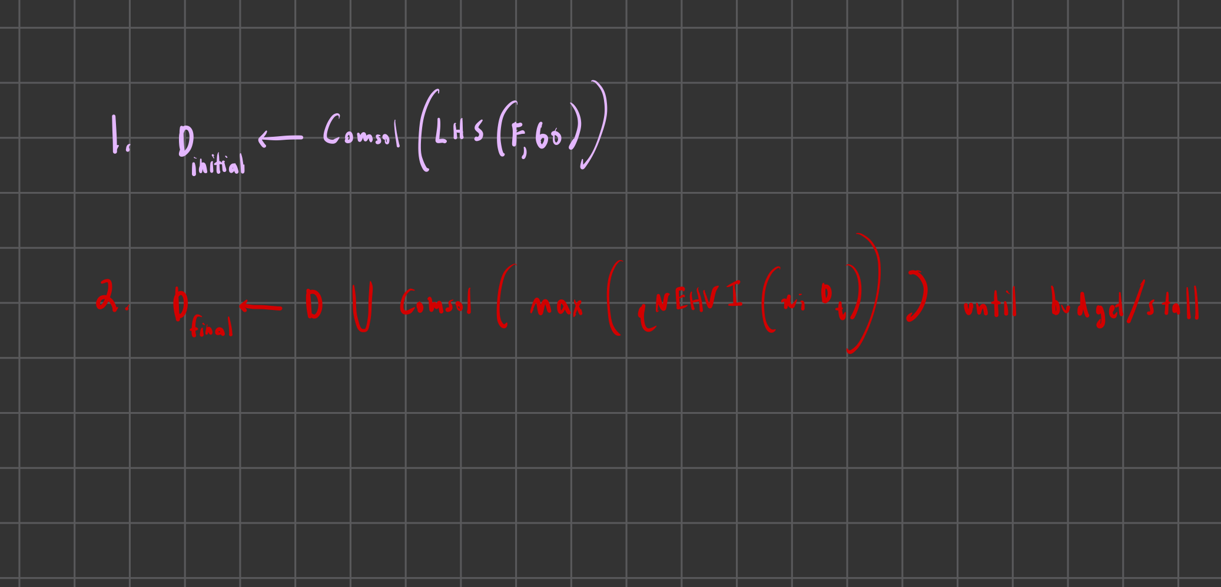
Stop criteria: Budget N_max reached, or improvement stalls (f_min unchanged over k batches, or HV stalls)

